10th **Annivarsary**

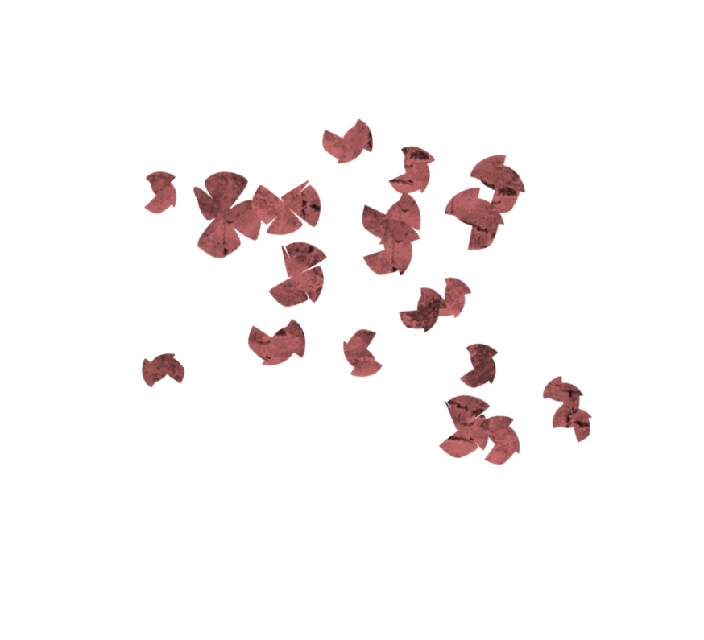

**of**

**Amberley Home and Retirement Cottages**

08/10/2016